

EE 463

STATIC POWER CONVERSION I

HARDWARE PROJECT FINAL REPORT

Orhun TAŞOĞLU 2094506

Mert ZEYBEK 2167682

Kutay DELİBAŞ 2093599

Submission Date: 15.01.2019

# Introduction

# Design Choices

After the simulation report is submitted and our suggested system topology is verified, some parts of the system needed to be designed in detail. PWM Generator, Optical Isolator & Gate Driver needed to be implemented to replace the PWM block in the simulation. Since we worked with real circuit elements, there were more elements which were not in the simulations but should be taken into consideration. Heat dissipation of semiconductors, stray inductances, placement of the components and ensuring proper connections were critical for proper and robust operation. Block by block, details about design choices are given in this section.

## Topology Selection

3-Phase Rectifier and Buck Converter topology with low side switching is used as it was proposed in the Simulation Reports. As expected, the motor provided enough filtering and it was proven that LC filter was not needed in our case. Making this decision saved us both time and money, since finding a suitable inductor in the market that is ready to purchase would be more or less impossible and it needed to hand wound. In other words, buying more components and spending extra time.

Implementing low-side switching eliminated the need for isolated supply, however an optocoupler is used in case. Moreover, it helped us eliminate the need for a second power supply. As a result, our design became less complex, using only one DC supply.

## PWM Generation

To generate PWM signal with adjustable duty cycle, TL494 IC is used. It is chosen since the chip is widely available (also in the laboratory), it is analog so does not require software programming and implementation is easy & understandable. A potentiometer is used to change the duty cycle which is actually a basic voltage divider. Difference between the potentiometer output and reference signal is used to calculate desired duty cycle by the IC. The circuitry is given is Figure X.

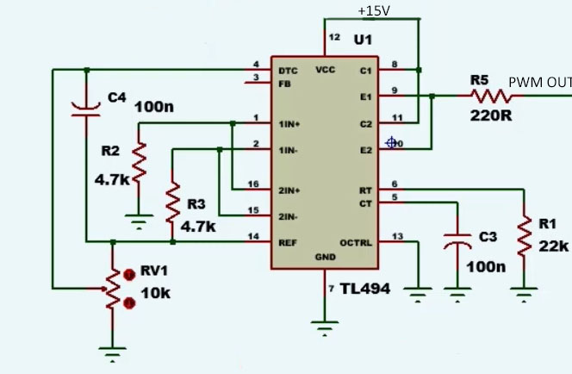

However, using this circuit to directly drive the IGBT would be impossible since TL494 can not supply the desired current to turn on the transistor. Therefore, additional circuitry was needed.

## Optocoupler & Gate Driver

A gate driver was needed to be able to use the generated PWM as the gate signal as mentioned. Also, to isolate the sensitive low voltage components from the high voltage paths where also high currents pass, using a optocoupler is a good security measure to prevent the components getting harmed in case of a failure.

An analog amplifier could have been used for gate signal part, but since TLP250 IC can handle both of our requirements, the IC is used, in the circuit given in Figure X.

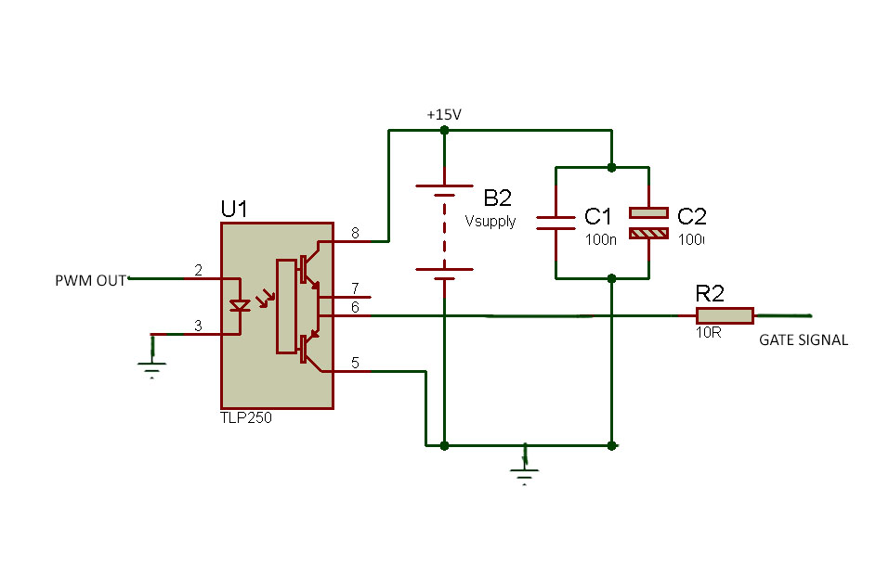

## Semiconductor Components Selection

## Other Components Selection

# Simulation Results

# Test Results

## Lab Tests

## Demo-Day Tests

# Cost Analysis

# Challenges

# Conclusion